Test Case: tc006_SPX_Dev5_Crear_Requisicion_Spot_Tipo_Cobro_Proyect_Urgent
Step 1 - Enter username and password and click to button Enter: Credentials Entered
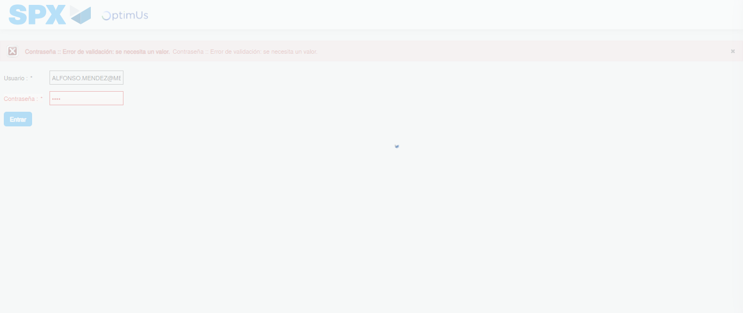Image file-name: QC_Testing-tc006_SPX_Dev5_Crear_Requisicion_Spot_Tipo_Cobro_Proyect_Urgent-1783361858863

Step 2 - Select to UEN and Access to Spot Buy Requisitions : UEN Correctly selected and Correct access
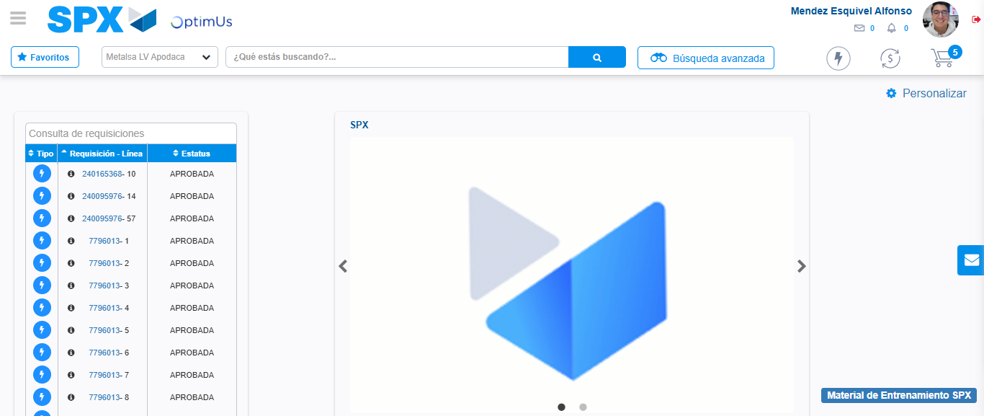Image file-name: QC_Testing-tc006_SPX_Dev5_Crear_Requisicion_Spot_Tipo_Cobro_Proyect_Urgent-1783361884494

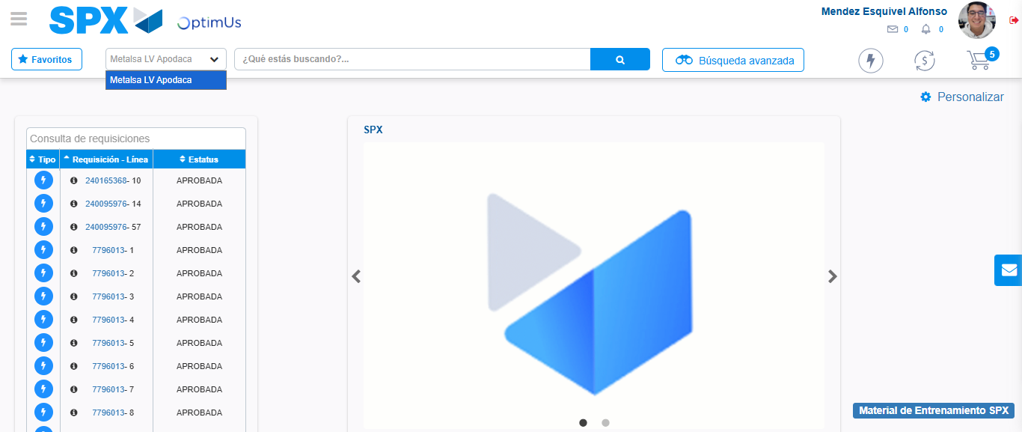Image file-name: QC_Testing-tc006_SPX_Dev5_Crear_Requisicion_Spot_Tipo_Cobro_Proyect_Urgent-1783361887209

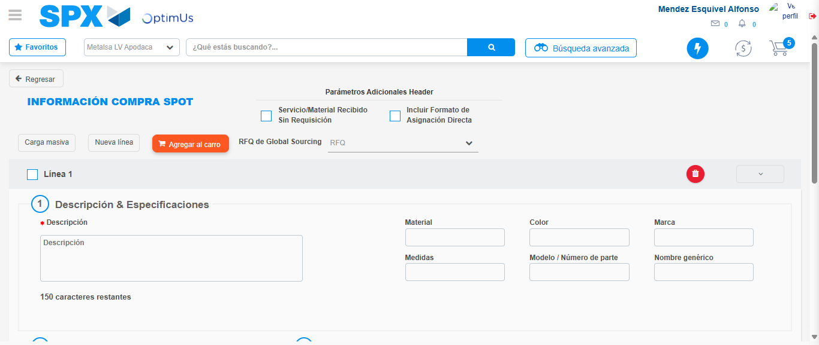Image file-name: QC_Testing-tc006_SPX_Dev5_Crear_Requisicion_Spot_Tipo_Cobro_Proyect_Urgent-1783361907962

Step 3 - Data Capture Spot Buy Requisition: Data captured correctly
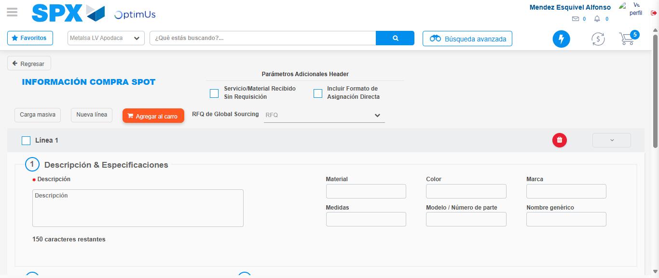Image file-name: QC_Testing-tc006_SPX_Dev5_Crear_Requisicion_Spot_Tipo_Cobro_Proyect_Urgent-1783361908317

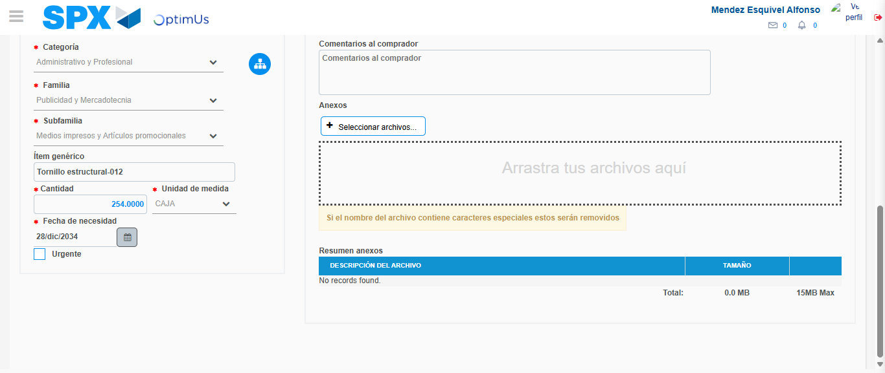Image file-name: QC_Testing-tc006_SPX_Dev5_Crear_Requisicion_Spot_Tipo_Cobro_Proyect_Urgent-1783361919242

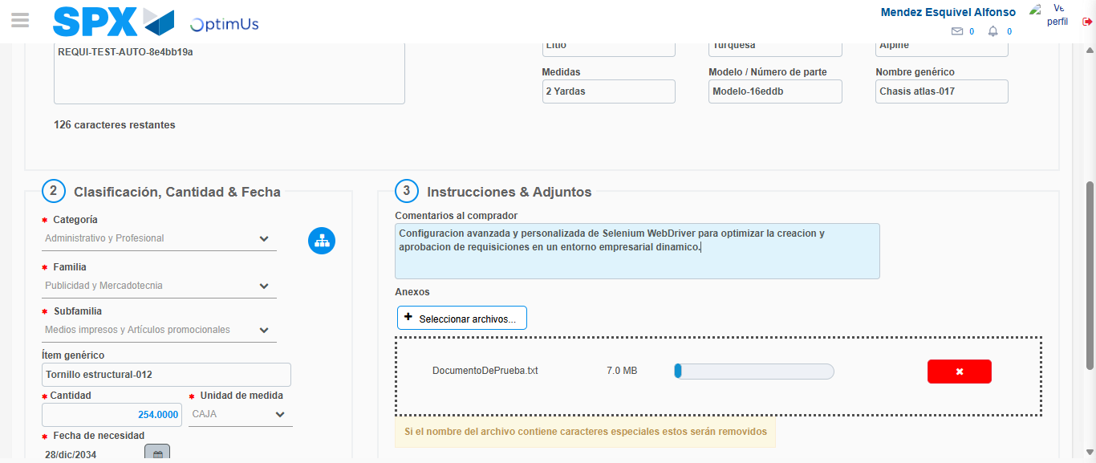Image file-name: QC_Testing-tc006_SPX_Dev5_Crear_Requisicion_Spot_Tipo_Cobro_Proyect_Urgent-1783361919985

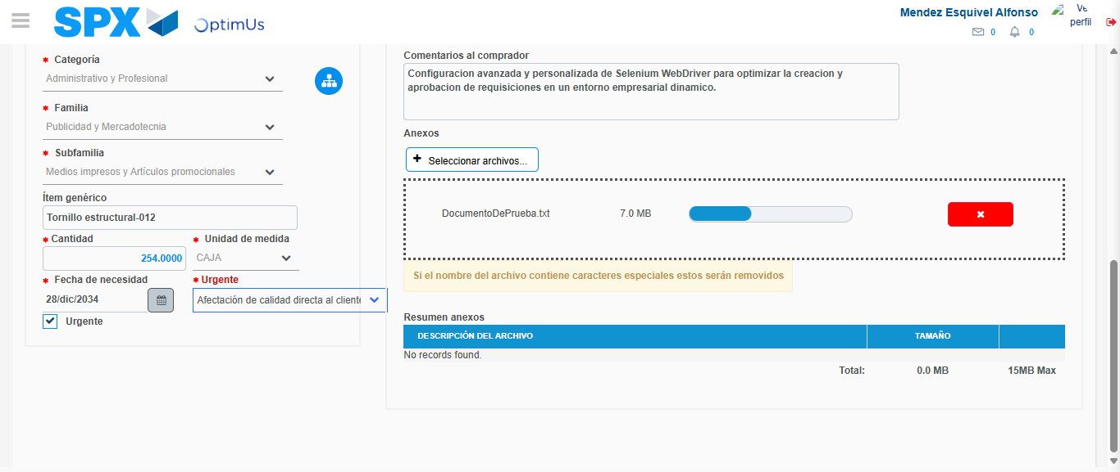Image file-name: QC_Testing-tc006_SPX_Dev5_Crear_Requisicion_Spot_Tipo_Cobro_Proyect_Urgent-1783361923157

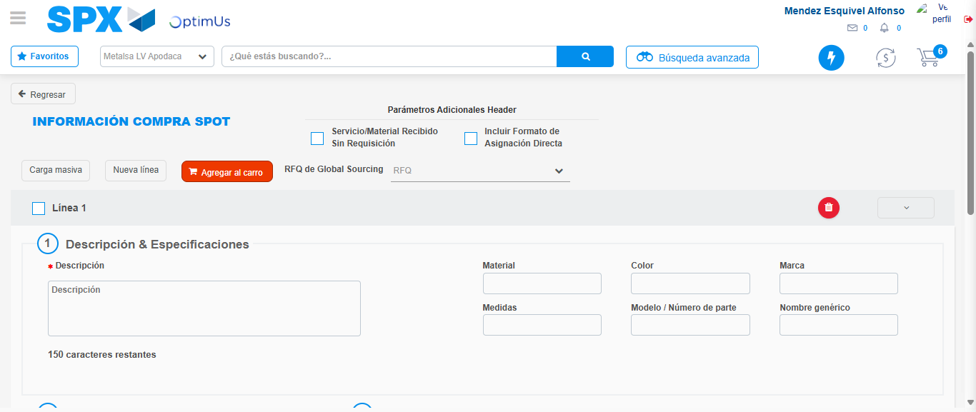Image file-name: QC_Testing-tc006_SPX_Dev5_Crear_Requisicion_Spot_Tipo_Cobro_Proyect_Urgent-1783361928511

Step 7 - Return to Main Page SPX : Return to Main Page SPX
Image file-name: QC_Testing-tc006_SPX_Dev5_Crear_Requisicion_Spot_Tipo_Cobro_Proyect_Urgent-1783361884494

Image file-name: QC_Testing-tc006_SPX_Dev5_Crear_Requisicion_Spot_Tipo_Cobro_Proyect_Urgent-1783361887209

Image file-name: QC_Testing-tc006_SPX_Dev5_Crear_Requisicion_Spot_Tipo_Cobro_Proyect_Urgent-1783361907962

Image file-name: QC_Testing-tc006_SPX_Dev5_Crear_Requisicion_Spot_Tipo_Cobro_Proyect_Urgent-1783361930737

Image file-name: QC_Testing-tc006_SPX_Dev5_Crear_Requisicion_Spot_Tipo_Cobro_Proyect_Urgent-1783361930926

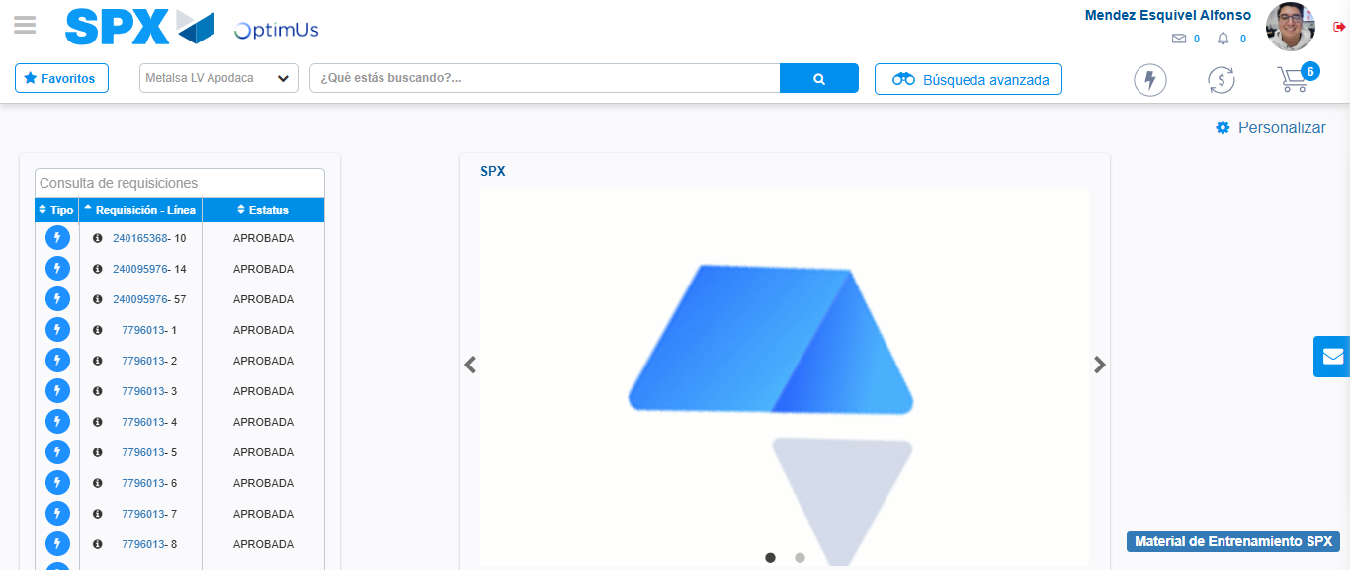Image file-name: QC_Testing-tc006_SPX_Dev5_Crear_Requisicion_Spot_Tipo_Cobro_Proyect_Urgent-1783361952054

Step 8 - Log Out : Log Out SPX
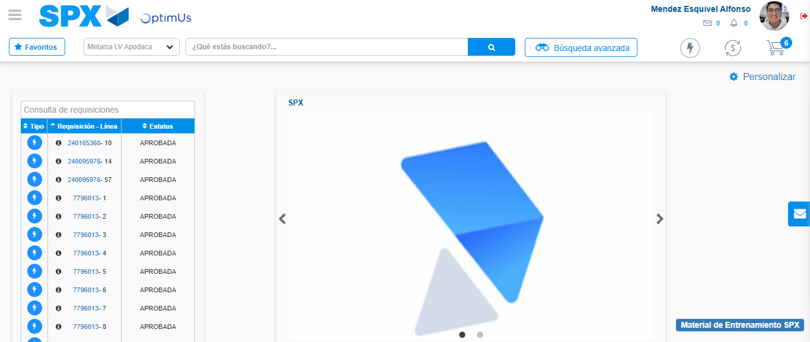Image file-name: QC_Testing-tc006_SPX_Dev5_Crear_Requisicion_Spot_Tipo_Cobro_Proyect_Urgent-1783361952307

